Workflow Functional Document

Application | NGERP - Centra
Workflow | Quote to Cash
Workflow Item Name | Reopen Period Request

Description:

In Compiere ERP, reopening a period refers to the process of allowing accounting entries to be posted to a previously closed period. By default, once a period is closed, users are typically prevented from making any further transactions or adjustments to it.

Workflow Process:

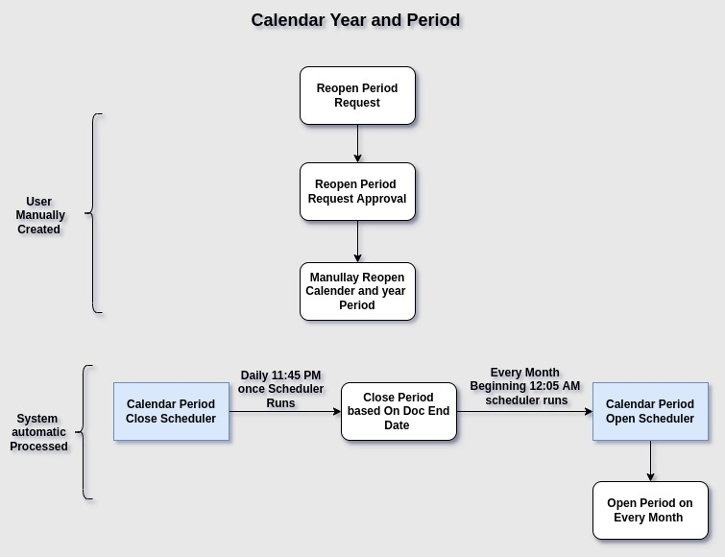

Business Rules:

- Every Month end Calendar Period Close Scheduler will runs (11:45 PM) and Closed the Previous month Document type Periods based on the Doc End Date.
- Every Beginning of the Month (12: 05 AM) Calendar Open Period Scheduler will runs and Open the
Document type periods.
- A Reopen Period request is used to open a previously closed period to allow further transactions.
- Create Re-Open Period Request and map Document type , Period , Requested date ,Role etc..he Reopen Period request requires approval to determine whether the request is valid. If valid, it should be approved
- Once the request is approved, the period will be manually opened in the Calendar and Year window.

